**PERSONAL PROFILE**

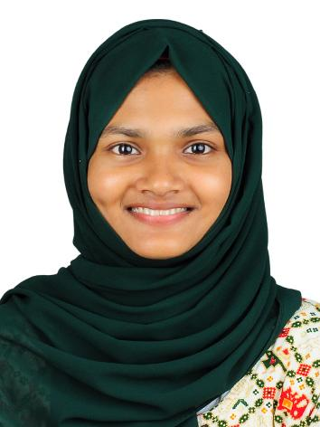

**NADUKKEPURAYIL,**

**ERINHIKKADAVU,**

**KAYARALAM P0**

**670602**

**ASIYA SIBGHATH K**

**Assistant Professor (On Contract)**

**Department of Journalism**

**Sir Syed College**

**Taliparamba**

Name : **ASIYA SIBGHATH K**

**M.A., NET.**

Age & Date of Birth : 25 & 02/06/1999

Gender : Female

Marital Status : Married

Nationality : Indian

Religion : Islam

Phone No : 6238538014

E-mail : asiyasibghath@gmail.com

Languages Known : English and Malayalam

**Book Published:**

**Education**

|  |  |  |  |  |
| --- | --- | --- | --- | --- |
| **Course** | | **Institution** | **Year** | **Specialization** |
| NET | UGC | | 2023 | Journalism and Mass Communication |
| MA | Department of JMS, Kannur University | | 2023 | Journalism and Mass Communication |
| BA | DGMMES College, Mampad (Autonomous) | | 2021 | Mass Communication |

**Experience**

|  |  |  |  |
| --- | --- | --- | --- |
| **Institution** | **Designation** | **From** | **To** |
| Majlis Arts and Science College, Puramannur | Assistant Professor | 01.08.2023 | 05.06.2024 |
|  |  |  |  |

**Online Courses Completed**

|  |  |
| --- | --- |
| **Course** | **Institution** |
|  |  |
|  |  |

**Areas of Research Interest**

Mass Communication, Development Communication, Film Studies

I hereby declare that above mentioned information are true to the best of my knowledge and belief.

Taliparamba

2023 **ASIYA SIBGHATH K**